Public Works Resources

Table of Contents (ctrl & click to follow link)

Air Conditioner/Heater 2
Air Curtain Burners (Fire Box-Above Ground, Refractory Walled) 4
Air Curtain Burners (Trench Burner, In-Ground) 5
All Terrain Cranes 6
Backhoe Loader 7
Chillers & Air Handlers (500 Ton to 50 Ton) 8
Concrete Cutter/Multi-Processor for Hydraulic Excavator 10
Crawler Cranes 11
Debris Management Monitoring Team 13
Debris Management Site Reduction Team 15
Debris Management Team 17
Disaster Assessment Team 19
Disaster Recovery Team 20
Dump Trailer
Dump Truck-Off Road 23
Dump Truck-On Road 25
Electrical Power Restoration Team
Engineering Services 27
Flat Bed Trailer Truck
Generators 29
Hydraulic Excavator (Large Mass Excavation 13 cy to 3 cy buckets) 31
Hydraulic Excavator (Medium Mass Excavation 4 cy to 1.75 cy buckets) 32
Hydraulic Truck Cranes 33
Lattice Truck Cranes 34
Track Dozer 35
Tractor Trailer
Tub Grinder 39
Tug Boat 40
Water Purification Team (USACE Emergency Water Teams) 41
Water Truck
Wheel Dozer 44
Wheel Loaders (Large 41 cy to 8 cy) 45
Wheel Loaders (Medium 7 cy to 3 cy) 46
Wheel Loaders (Small 7 cy to 2 cy) 47

Resource: Air Conditioner/Heater
Category: |  | Public Works and Engineering (ESF #3) |  |  |  | Kind: | Equipment
Minimum Capabilities: |  |  | Type I | Type II | Type III |  |  | Type IV | Other
Component | Metric |  | 90 Ton  Air conditioner/heater; 90 Ton Air Cooled Direct Expansion portable A/C unit w/ heat; 26,000 cfm (cubic feet per minute) of air delivered; Weight: 19,900 lbs; Can be trailer mounted (flat bed semi) dimensions: 20’ Long x 8’ Wide x 9’.5” Tall; Power requirements: Cooling only 260 Amps at 460 volts, 3 phase, 60 hz; Heat only (250 kW) 368 Amps at 460 volts, 3 phase, 60 hz;  (8) 20” Flex duct connections for air supply (4)/ return (4);  Potential application examples: Airports, Universities, Malls, Moisture removal from wet buildings & materials (weather / temperature permitting).  Setup time varies depending on duct installation, fabricating, wiring, etc…2+ hours;  4/0 Cam-Lock type quick connect cable used for power termination to source. | 60 Ton  Air conditioner/heater; 60 Ton Air Cooled Direct Expansion portable A/C unit w/ heat; 17,000 cfm (cubic feet per minute) of air delivered; Weight: 16,500 lbs; Can be trailer mounted (flat bed semi) dimensions: 20’ Long x 8’ Wide x 8’.5” Tall. Power requirements: Cooling only 160 Amps at 460 volts, 3 phase, 60 hz; Heat only (125 kW) 200 Amps at 460 volts, 3 phase, 60 hz;  (8) 20” Flex duct connections for air supply (4)/ return (4); Potential application examples: Airports, Retail stores, Schools, Moisture removal from wet buildings & materials (weather / temperature permitting).  Setup time varies depending on duct installation, fabricating, wiring, etc…2+ hours;  4/0 Cam-Lock type quick connect cable used for power termination to source. | 25 Ton  Air conditioner/heater; 25 Ton Air Cooled Direct Expansion portable A/C unit w/ heat; 9,400 cfm (cubic feet per minute) of air delivered; Weight: 4,140 lbs; Can be trailer mounted (flat bed tow behind) dimensions: 12’ Long x 7’.6” Wide x 5’ Tall; Power requirements: Cooling only 60 Amps at 460 volts, 3 phase, 60 hz; Heat only (72 kW) 100 Amps at 460 volts, 3 phase, 60 hz; (4-6) 20” Flex duct connections for air supply (2)/ return (2-4);  Potential application examples: Tents, Small retail stores, Libraries, Moisture removal from wet buildings & materials (weather / temperature permitting).  Setup time varies depending on duct installation, fabricating, wiring, etc…2+ hours;  4/0 Cam-Lock type quick connect cable used for power termination to source. |  |  | 10 Ton  Air conditioner / heater; Caterpillar/York 10 Ton Air Cooled Direct Expansion portable A/C unit w/ heat; 4,000 cfm (cubic feet per minute) of air delivered; Weight: 1,500 lbs; Can be trailer mounted (flat bed tow behind) dimensions: 11’ Long x 6’.5” Wide x 5’ Tall; Power requirements: Cooling only 24 Amps at 460 volts, 3 phase, 60 hz; Heat only (54 kW) 71 Amps at 460 volts, 3 phase, 60 hz; (3) 20” Flex duct connections for air supply (1)/ return (2);  Potential application examples: Tents, Computer rooms, Small office (2,000 sq. ft.), Moisture removal from wet buildings & materials (weather / temperature permitting). Setup time varies depending on duct installation, fabricating, wiring, etc…2+ hours;  4/0 Cam-Lock type quick connect cable used for power termination to source.
Equipment | Ton
Comments: | 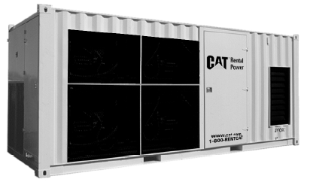  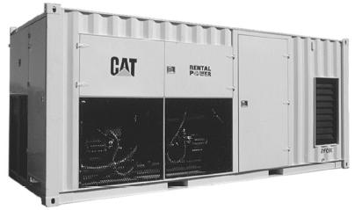  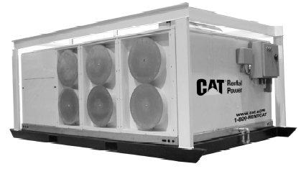  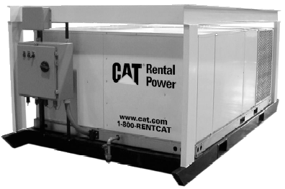

Resource: Air Curtain Burners (Fire Box-Above Ground, Refractory Walled)
Category: |  | Public Works and Engineering (ESF #3) |  |  |  |  | Kind: |  | Equipment
Minimum Capabilities: |  |  | Type I | Type II |  | Type III |  | Type IV |  | Type V |  | Type VI
Component | Metric |  | S-327 | S-321 |  | S-220 |  | S-217 |  | S-116 |  | S-111
Equipment | Tons/Hr |  | Dimensions:  Overall L×W×H:  37'4"×11'10"×9'7"  Firebox:  27'2”×8'5"×8'1"  Weight:  50,000 lbs  Avg. Thru-put:  6-10 tons/hr  Engine:  Perkins 1004.42  Fuel: Diesel,  ≈ 3 gal/hr  Unit is shipped completely assembled; transportable by drop-deck trailer | Dimensions:  Overall L×W×H:  31'4"×11'10"×9'7"  Firebox:  21’2”×8'5"×8'1"  Weight:  46,000 lbs  Avg. Thru-put:  5-8 tons/hr  Engine:  Perkins 1004.42  Fuel: Diesel,  ≈ 3 gal/hr  Unit is shipped completely assembled; transportable by drop-deck trailer |  | Dimensions:  Overall L×W×H:  30'2"×8’6"×8'6"  Firebox:  19’8”×6'2"×7'1"  Weight:  33,500 lbs  Avg. Thru-put:  3-6 tons/hr  Engine:  Perkins 404C  Fuel: Diesel,  ≈ 2.5 gal/hr  Unit is shipped completely assembled transportable by flatbed or tilt bed tag trailer |  | Dimensions:  Overall L×W×H:  27’×8’6"×8'6"  Firebox:  16’5”×6'2"×7'1"  Weight:  30,000 lbs  Avg. Thru-put:  2-5 tons/hr  Engine:  Perkins 404C  Fuel: Diesel,  ≈ 2.5 gal/hr  Unit is shipped completely assembled transportable by flatbed or tilt bed tag trailer |  | Dimensions:  Overall L×W×H:  27’×7’5"×7’8"  Firebox:  16'×5'×6'  Weight:  26,000 lbs  Avg. Thru-put:  1-4 tons/hr  Engine:  Perkins 404C  Fuel: Diesel,  ≈ 2.5 gal/hr  Unit is shipped completely assembled transportable by flatbed or tilt bed tag trailer |  | Dimensions:  Overall L×W×H:  21’6”×7’5"×7’8"  Firebox:  11'×5'×6'  Weight:  21,300 lbs  Avg. Thru-put:  ½-2 tons/hr  Engine:  Perkins 404C  Fuel: Diesel,  ≈ 2.5 gal/hr  Unit is shipped completely assembled transportable by flatbed or tilt bed tag trailer
 |  |  | Application:  Wood Waste Reduction & Animal Carcass Disposal (needs wood waste to support carcass combustion) | Application:  Wood Waste Reduction & Animal Carcass Disposal (needs wood waste to support carcass combustion) |  | Application:  Wood Waste Reduction & Animal Carcass Disposal (needs wood waste to support carcass combustion) |  | Application:  Wood Waste Reduction & Animal Carcass Disposal (needs wood waste to support carcass combustion) |  | Application:  Wood Waste Reduction & Small Animal Carcass Disposal (needs wood waste to support carcass combustion) |  | Application:  Wood Waste Reduction & Small Animal Carcass Disposal (needs wood waste to support carcass combustion)
 |  |  | On GSA Schedule | On GSA Schedule |  | On GSA Schedule |  | On GSA Schedule |  | On GSA Schedule |  | On GSA Schedule
Comments: | 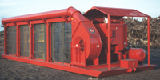 |  |  |  | 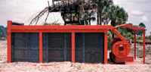 |  |  |  |  |  | 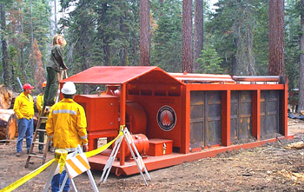
Comments: | S-300 Series  (Type I & II) |  |  |  | S-200 Series  (Type II & III) |  |  |  |  |  | S-100 Series  (Type IV & V)

Resource: Air Curtain Burners (Trench Burner, In-Ground)
Category: |  | 1 Public Works and Engineering (ESF #3) |  |  |  |  | Kind: | Equipment
Minimum Capabilities: |  |  | Type I | Type II | Type III |  |  |  | Type IV | Other
Component | Metric |  | T-400 | T-200 | T-350
Equipment | Tons/HR |  | Dimensions:  Overall L×W×H:  28’×8'1"×6'10"  Pit or Trench:  40'×10'×12’  Weight:  6,900 lbs  Tongue:  1,400 lbs  Avg. Thru-put:  5-8 tons/hr  Engine:  Kubota V3300E  Fuel: Diesel,  ≈ 3 gal/hr  Unit is dual-axle trailer-mounted; 2 5/8” ball hitch or pintle hitch;  electric brakes | Dimensions:  Overall L×W×H:  28'×8'1"×6'10"  Pit or Trench:  20'×10'×10'  Weight:  4,900 lbs  Tongue:  890 lbs  Avg. Thru-put:  1-4 tons/hr  Engine:  Perkins 404C  Fuel: Diesel,  ≈ 2.5 gal/hr  Unit is dual-axle trailer-mounted; 2 5/8” ball hitch or pintle hitch;  electric brakes | Dimensions:  Overall L×W×H:  18'9”×8’2”×8’7”  Pit or Trench:  35'×12’×12'  Weight:  7,000 lbs  Tongue:  1,200 lbs  Avg. Thru-put:  4-7 tons/hr  Engine:  Perkins 1004.42  Fuel: Diesel,  ≈ 3 gal/hr  Unit is dual-axle trailer-mounted; 2 5/8” ball hitch or pintle hitch;  electric brakes
 |  |  | Application:  Wood Waste Reduction & Animal Carcass Disposal (needs wood waste to support carcass combustion) | Application:  Wood Waste Reduction & Animal Carcass Disposal (needs wood waste to support carcass combustion) | Application:  Wood Waste Reduction & Animal Carcass Disposal (needs wood waste to support carcass combustion)
 |  |  | On GSA Schedule | On GSA Schedule
Comments: | 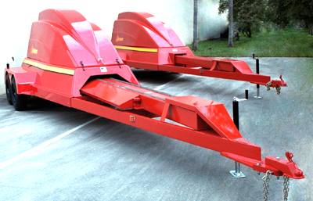 |  |  |  |  | 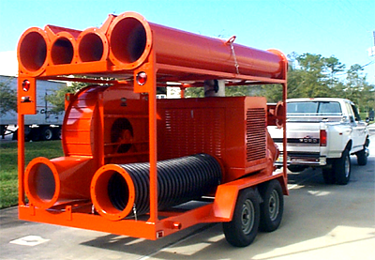
Comments: | T-400 & T200 (Type I & II) |  |  |  |  | T-350 (Type III)

Resource: All Terrain Cranes
Category: |  | Public Works and Engineering (ESF #3) |  |  |  | Kind: | Equipment; Personnel; Vehicle
Minimum Capabilities: |  |  | Type I | Type II | Type III |  |  | Type IV | Other
Component | Metric
Equipment & Personnel | Tons |  | 210-175  Crane type with boom reach of 170 feet. With jib reaches to approx. 280 feet. Self-propelled/driven over the road. Operator furnished. Setup time minimal. Jib and counter-weight are transported by two tractor-trailers | 50-120  Crane type with boom reach of 150 feet. With jib reaches to approx. 250 feet. Self-propelled/driven over the road. Operator furnished. Setup time minimal. Jib and counter-weight are transported by two tractor-trailers | 110-90  Crane type with boom reach of 192 feet. With jib add approx. 30 feet. Self-propelled/driven over the road. Operator furnished. Setup time minimal. Jib and counter-weight are transported by two tractor-trailers |  |  | 22.5  Crane type with boom reach of 90 feet. With jib add approx. 30 feet. Self-propelled/driven over the road. Operator furnished. Setup time minimal
Comments: | Check with your local/State transportation and law enforcement organizations to determine mobilization requirements.
 | 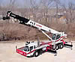

Resource: Backhoe Loader
Category: | Public Works and Engineering (ESF #3) |  |  |  |  | Kind: | Equipment
Minimum Capabilities: |  |  | Type I | Type II | Type III |  |  | Type IV | Other
Component |  | Metric
Example |  |  | 446B – Cat 3114T Diesel | 420D – Cat 3054T Diesel | 420D IT with Quick Coupler – Cat 3054T Diesel |  |  | 416D – Cat 3054B Diesel, Gross Power
Gross Power |  | kw/hp | 82/110 | 66/88 | 66/88 |  |  | 58/77
Operating Weight (max) |  | lbs | 19,630 | 15,772 | 15,772 |  |  | 15,257
Dig Depth Standard Stick |  | ft/in | 14’5” | 14’5” | 14’5” |  |  | 14’5”
Extended Stick |  | ft/in | 18’1” | 18’1” | 18’1” |  |  | 18’1”
Loading Height |  | ft/in | 11’10” | 11’10” | 11’10” |  |  | 11’10”
Loading Reach |  | ft/in | 5’8” | 5’8” | 5’8” |  |  | 5’8”
Bucket Capacity |  | yd³ | 1.25 | 1.25 | 1.25 |  |  | 1.25
Dump Height (max angle) |  | ft/in | 8’4” | 8’4” | 8’1” |  |  | 8’4”
Dump Reach (max angle) |  | ft/in | 2’9” | 2’9” | 2’10” |  |  | 2’9”
Lift Capacity (full height) |  | lbs | 6,385 | 6,385 | (w/QC)  6,970 |  |  | 5,292
Bucket Breakout Force |  | lbs | 10,131 | 10,131 | 10,564 |  |  | 8,524
Fuel Capacity |  | gal | 34 | 34 | 34 |  |  | 34
Comments: |  | Caterpillar is used as an example only.  420 IT tools include the following:  Backhoe Work Tools: Buckets – Standard, Heavy Duty, Heavy Duty Rock, High Capacity, Coral, Ditch Cleaning; Hydraulic Hammer; Vibratory Plate Compactor; Ripper.  Loader Work Tools: Buckets – General Purpose, Multipurpose, Side Dump, Light Material, Penetration; Loader Forks; Material Handling Arm; Angle Blade; Broom; Rake; Asphalt Cutter; Bale Spear.  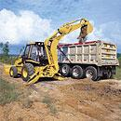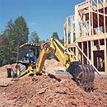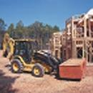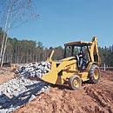  446B 420D 420D IT 416 D

Resource: Chillers & Air Handlers (500 Ton to 50 Ton)
Category: |  | Public Works and Engineering (ESF #3) |  |  |  |  |  | Kind: |  |  | Equipment
Minimum Capabilities: |  |  | Type I |  | Type II |  | Type III |  | Type IV |  |  | Type V |  | Type VI
Component | Metric
Equipment | Ton |  | 500/450 Ton Chiller Caterpillar/York 450/500 Ton Air Cooled Chiller; Built-in pump delivering 330-1600 gpm (gallons per minute); Will operate in series or parallel operation w/multiple units;  8” flanged water fittings on exterior; Weight: 50,000 lbs; Trailer mounted (semitractor) dimensions: 40’ Long x 8’.5” Wide x 13’.5” Tall; Power requirements: 800-980 Amps at 460 volts, 3 phase, 60 hz; Temporary quick connect chilled water hose available with unit for tie in to chilled water system; Potential application examples: Single or multiple units for Computer centers, High-rise buildings, Heavy manufacturing, Airports, Universities.  Setup time varies depending on hose installation, water filling, fabricating, etc…4+ hours; 4/0 Cam-Lock type quick connect cable used for power termination to source |  | 300 Ton Chiller Caterpillar/York 300 Ton Air Cooled Chiller; Built-in pump(s) delivering 250-800 gpm;  6” flanged water fittings on exterior; Weight: 33,000 lbs; Trailer mounted (semitractor) dimensions: 30’ Long x 8’ Wide x 13’.5” Tall; Power requirements: 600-700 Amps at 460 volts, 3 phase, 60 hz; Temporary quick connect chilled water hose available with unit for tie in to chilled water system; Potential application examples: Single or multiple units for Office buildings, Multi-story buildings, Schools, Temporary structures, Retail stores.  Setup time varies depending on hose installation, water filling, fabricating, etc…3+ hours; 4/0 Cam-Lock type quick connect cable used for power termination to source |  | 150 Ton Chiller Caterpillar/York 150 Ton Air Cooled Chiller; Built-in pumps delivering 250-700 gpm;  6” flanged water fittings on exterior; Weight: 31,000 lbs; Trailer mounted (semitractor) dimensions: 20/30’ Long x 8’ Wide x 12’.5” Tall; Power requirements: 329-400 Amps at 460 volts, 3 phase, 60 hz; Temporary quick connect chilled water hose available with unit for tie in to chilled water system; Potential application examples: Single or multiple units for Medium office buildings, Libraries, Hotels/motels, Condominiums, Retail stores.  Setup time varies depending on hose installation, water filling, fabricating, etc…2+ hours; 4/0 Cam-Lock type quick connect cable used for power termination to source |  | 50 Ton Chiller Caterpillar/York 50 Ton Air Cooled Chiller; Built-in pump delivering 75-200 gpm;  4” quick connect water fittings on exterior; Weight: 5,500 lbs.; Skid mounted w/ forklift pockets (8,000 lb. lift recommended) dimensions: 12’ Long x 7’.5” Wide x 8’.5” Tall; Power requirements: 125 Amps at 460 volts, 3 phase, 60 hz; Temporary quick connect chilled water hose available with unit for tie in to chilled water system. Potential application examples: Single or multiple units for Small office buildings, Tent/shelter cooling, Small-medium retail stores.  Setup time varies depending on hose installation, water filling, fabricating, etc…2+ hours; 4/0 Cam-Lock type quick connect cable used for power termination to source |  |  | Custom Rental Air Handling Units: 50, 75, & 100 Tons  For delivering cold air with use of any chiller, 5,000-30,000 cfm depending on unit;  20” diameter flex duct inlets/outlets for air distribution supply/return; 4/0 Cam-Lock type quick connect cable used for power termination to source; Call for power requirements and sizing; Potential application examples: Single or multiple units for buildings w/out HVAC systems, Tent/shelter cooling, etc  Setup time varies on application 1-2 hours each
Comments: | Caterpillar equipment used for typing. Equipment not available at all locations, but CAT dealer network can acquire equipment from one another and ship. Need fresh water source for filling chilled water system. Temporary chilled water hose & 4/0 power cable available for chillers. Set up & monitoring available. Low Temp Chillers and Cooling Towers available. Air handlers require use of chillers or chilled water supply to operate.
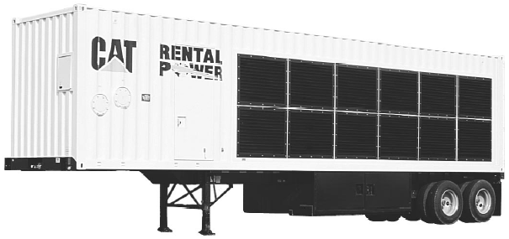
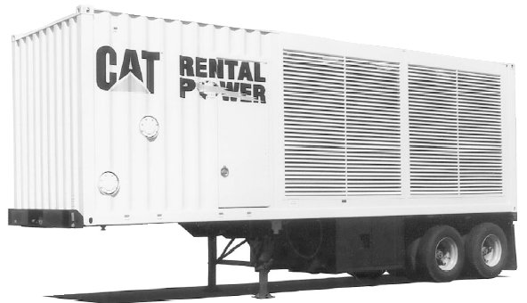
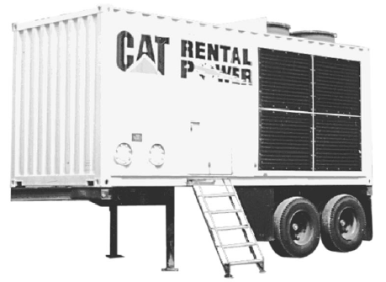
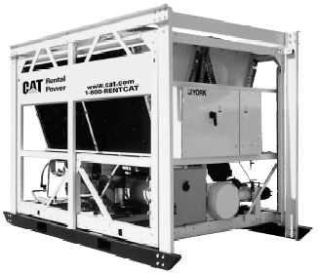
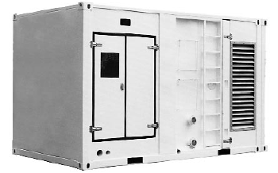
 | 500/450 Ton |  |  | 300 Ton |  | 150 Ton |  |  |  | 50 Ton |  |  | Custom Rental Air Handling Unit

Resource: Concrete Cutter/Multi-Processor for Hydraulic Excavator
Category: |  | Public Works and Engineering |  |  |  | Kind: | Equipment
Minimum Capabilities: |  |  | Type I | Type II | Type III |  |  | Type IV | Other
Component | Metric |  | MP40 CC (Largest) | MP30 CC | MP20 CC |  |  | MP15 CC (smallest)
Jaw Opening | Inches |  | 50.4 | 38.4 | 32 |  |  | 26
Jaw Depth | Inches |  | 43.3 | 35 | 31 |  |  | 26
Force at Tooth Tip | Short Ton |  | 168 | 140 | 107 |  |  | 79
Force Primary Blade Center | Short Ton |  | 494 | 460 | 337 |  |  | 247
Weight of Jaw | Pounds |  | 4,850 | 7,935 | 5,730 |  |  | 3,970
Weight With housing | Pounds |  | 12,785 | 20.5 | 18 |  |  | 16
Cutter Length | Inches |  | 23.6 | 110.2 | 95 |  |  | 87
Length | Inches |  | 137.8 | 208 | 157 |  |  | 112
Force At Cutting Tip | Short Ton |  | 247 | 2,865 | 2,205 |  |  | 1,430
Max Op Pres Hyd. Cylinder | Pressure Per Square Inch |  | 5,075 | 5,075 | 5,075 |  |  | 5,075
Maximum Oil flow Cylinder | Gallons Per Minute |  | 106 | 79 | 53 |  |  | 40
Maximum Oil flow Cylinder | Cycle - Seconds |  | 7.5 | 6.5 | 6 |  |  | 5
Maximum Operating Pressure Rotator | Pressure Per Square Inch |  | 2,030 | 2,030 | 2,030 |  |  | 2,030
Maximum Oil Flow Rotator | Gallons per minute |  | 22 | 11 | 11 |  |  | 11
For Use on Models |  |  | 375, 375 L  Hydraulic  Excavators | 345B L Series II  Hydraulic  Excavators | 322C L, 325C L  Hydraulic  Excavators |  |  | 321 B LCR, 322C  L Hydraulic  Excavators
Comments: | Multiprocessors do the work of many types of demolition tools by use of interchangeable jaw sets. Changing jaws allows a single unit to crush, pulverize, and perform a variety of specialized cutting tasks, such as cutting steel rebar and tanks. Check with Cat dealer/owner to match Multiprocessor model attachment to Hydraulic Excavator.
 | 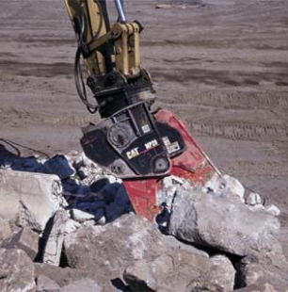

Resource: Crawler Cranes
Category: |  | Public Works and Engineering (ESF #3) |  |  |  | Kind: | Equipment; Personnel; Vehicle
Minimum Capabilities: |  |  | Type I | Type II | Type III |  |  | Type IV | Other
Component | Metric
Equipment & Personnel | Tons |  | 200  (Manitowoc 777) with a boom reach of 300 feet Operator with one (1) oiler/rigger. Requires nine (9) tractor-trailers to mobilize & demobilize. Setup time six (6) hours. | 100  (Manitowoc 222) with a boom reach of 300 feet Operator with one (1) oiler/rigger. Requires four (4) tractor-trailers to mobilize & demobilize. Setup time four (4) hours. | 80  (Manitowoc 111) with a boom reach of 300 feet Operator with one (1) oiler/rigger. Requires four (4) tractor-trailers to mobilize & demobilize. Setup time two (2) hours.
Comments: | Check with your local/State transportation and law enforcement organization to determine mobilization requirements.
 | 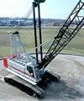

Resource: Debris Management Monitoring Team
Category: | Public Works and Engineering (ESF #3) |  |  |  | Kind: | Team; Personnel
Minimum Capabilities: |  | Type I | Type II | Type III |  |  | Type IV | Other
Component | Metric
Services | Annual Contracts;  Per Unit; Hourly;  Lump Sum | General Manager (GM)  GM responsibility would include overall coordination with all levels of government and other ESFs; Knowledge of the Federal Response Plan and Federal response and recovery procedures related to debris management; Site monitoring of health and safety requirement in meeting local, State, or Federal standards during any and all parts of the recovery process whether from manmade or natural occurrences; Appropriate standards for the debris processing and disposal to successfully complete the recovery process of an event; Ability to manage and oversee owner’s current debris removal operations plan; Highest trained in debris monitoring management and recovery operations; Highest experience level in meeting Federal record keeping requirements and processing procedures; Highest knowledge in managing multiple service levels of manmade and or natural disasters; Financial capabilities to manage progressive monitoring processes; Required and necessary liability coverage for all aspects of operation; Highest ability to manage work programs and personnel safely, with the highest regard to safety and applicable regulations protecting employees of the company and community; Highest capabilities to recruit support staffing within acceptable timeframe | Project Manager (PM)  PM responsibility would include overall management of all taskings under the project to include removal, reduction and disposal/salvage operations. Monitors changes in the scope of original assignment, cost estimates, coordinating the procurement process, scheduling, tracking of funds, and reporting all elements of work progress; Knowledge of the Federal Response Plan and Federal response and recovery procedures related to debris management; Monitors and assures that health and safety procedures and requirements meet local, State, or Federal standards during any and all parts of the recovery process whether from manmade or natural occurrences; Monitors the compliance of debris processing and disposal to successfully complete the recovery process of an event; Ability to manage and oversee owner’s current debris removal operations plan; Highest trained in debris project management and recovery operations; Highest experience level in meeting Federal record keeping requirements and processing procedures; Highest ability to manage work programs and personnel safely, with the highest regard to safety and applicable regulations protecting employees of the company and community
Equipment |  | Ability to supply, support, and maintain an inventory of varying equipment specialties in assisting the handling of all aspects of monitoring for health and safety of personnel involved with recovery operations | Ability to support and maintain an inventory of varying equipment specialties in assisting the handling of all aspects of monitoring the health and safety of personnel involved with recovery operations
Personnel |  | The highest trained and experienced in the field of debris management procedures; Very good communication skills and the ability to effectively brief high level officials; Highest capability to train and manage assisting resources; Highest ability to comply with all local, State, Federal authority, and OSHA regulations to which services are being applied; No use restriction as it relates to assignment; Fully mobilized and fully equipped; Permanently assigned to completion of task on rotation, 30/3 | Trained and experienced in the field of debris management procedures; Very good communication skills; Highest capability to manage assisting resources; General understanding of equipment leasing contracts, various type of equipment, and unit price contracts. Highest ability to comply with all local, State, Federal authority, and OSHA regulations to which services are being applied; No use restriction as it relates to assignment; Fully mobilized and fully equipped; Have an engineering background with a background in site development and proven skills in the field of construction; Permanently assigned to completion of task on rotation, 30/3
Comments:

Resource: Debris Management Site Reduction Team
Category: | Public Works and Engineering (ESF #3) |  |  |  |  | Kind: | Team
Minimum Capabilities: |  |  | Type I | Type II | Type III |  |  | Type IV | Other
Component |  | Metric
Storage Area Capabilities |  |  | Ability to establish lined temporary storage areas for ash, household hazardous waste, fuels, and other materials that can contaminate soils, runoff, or ground water
Control Capabilities |  |  | Ability to establish traffic control, dust control, erosion control, fire protection, on-site roadway maintenance, and safety measures
Debris Reduction |  |  | Ability to burn debris through air curtain incineration; Use of tub grinders to reduce disaster debris waste, and other source reduction applications to be site/disaster-specific
Sorting and Stockpiling |  |  | Ability to sort and stack debris at the site
Disposal |  |  | Ability to dispose nonburnable debris and ash residue
Clearance |  |  | Ability to clear site of all debris
Equipment |  |  | Ability to supply, support, and maintain an inventory of varying equipment specialties to facilitate and coordinate the removal, collection, and disposal of debris
Personnel |  |  | Trained and experienced in the field of debris management procedures; Understanding of equipment leasing contracts, various types of equipment, and unit price contracts; Ability to comply with Federal, State, and local authority, and OSHA regulations to which services are being applied; Ability to be fully mobilized and equipped; Engineering background with a background in site development and proven skills in construction; Knowledge of soil and water sampling and other environmental impacts; Knowledge and ability to ensure environmental justice protocols are upheld; Knowledge and expertise to perform varying debris reduction separation techniques, including, at minimum, 4 categories: woody vegetative debris, construction or building rubble, hazardous materials, and recyclable materials (e.g., aluminum, cast iron, steel, or household white goods or appliances); Appropriate education and training in managing inspection stations located at such debris reduction sites, recycling locations, or temporary debris staging reduction sites
Comments: |  | Debris Management Site Reduction Teams should possess the experience and financial capabilities to support equipment, disaster debris waste reduction capabilities, and personnel, and to maintain operations for an indefinite period of time. As only one type, the makeup of the Debris Management Site Reduction Team will be dependent on the site and impact specifics of the disaster.

Resource: Debris Management Team
Category: |  | Public Works and Engineering (ESF #3) |  |  |  | Kind: | Team
Minimum Capabilities: |  |  | Type I | Type II | Type III |  |  | Type IV | Other
Component | Metric
Services | Annual Contracts;  Per Unit; Hourly; Lump Sum |  | Long & Short Term  Management of national and international situations and events for manmade and natural occurrences that would produce debris requiring the resources to successfully complete the recovery process of debris management; Maintains a current and active debris removal operations plan; Highest training in debris management and recovery operations; Highest experience level in meeting Federal record keeping requirements and processing procedures; Highest knowledge in managing multiple service levels of manmade and/or natural disasters; Financial capabilities to manage progressive recovery processes; Has required and necessary liability coverage for all aspects of operation; Highest ability to manage work programs and its personnel safely and with the highest regard to safety and applicable regulations protecting employees of the company and community; Highest capabilities to recruit support staffing within acceptable timeframe; Mobilization timeframe: 24 hours—25%  48 hours—75%, 72 hours—100%; Debris removal will commence following the first 24 hours | Long & Short Term  Management of national and international situations and events for manmade and natural occurrences that would produce debris requiring the resources to successfully complete the recovery process of debris management; Maintains a current and active debris removal operations plan; Highest training in debris management and recovery operations; Highest experience level in meeting Federal record keeping requirements and processing procedures; Highest knowledge in managing multiple service levels of manmade and or natural disasters; Financial capabilities to manage progressive recovery processes; Has required and necessary liability coverage for all aspects of operation; Highest ability to manage work programs and its personnel safely and with the highest regard to safety and applicable regulations protecting employees of the company and community; Highest capabilities to recruit support staffing within acceptable timeframe; Mobilization timeframe: 24 hours—25%,  48 hours—50%, 72 hours—75%, 96 hours―100%; Debris removal will commence following the first 24-36 hours | Long & Short Term  Management of national and international situations and events for manmade and natural occurrences that would produce debris requiring the resources to successfully complete the recovery process of debris management; Management of multiple community resources through its management teams; Maintains a current and active debris removal operations plan; Highest training in debris management and recovery operations; Highest experience level in meeting Federal record keeping requirements and processing procedures; Highest knowledge in managing multiple service levels of manmade and or natural disasters; Financial capabilities to manage progressive recovery processes; Has required and necessary liability coverage for all aspects of operation; Highest ability to manage work programs and its personnel safely and with the highest regard to safety and applicable regulations protecting employees of the company and community; Highest capabilities to recruit support staffing within acceptable timeframe; Mobilization timeframe: 36 hours—25%, 48 hours—50%, 72 hours—75%, 96 hours—100%; Debris removal will commence following the first 24-36 hours
Equipment |  |  | Ability to supply, support, and maintain an inventory of varying equipment specialties in handling all aspects of disaster recovery | Ability to supply, support, and maintain an inventory of varying equipment specialties in handling all aspects of disaster recovery | Utilization of all available community support equipment; Ability to supply, support, and maintain additional inventory of varying equipment specialties in handling all aspects of disaster recovery
Personnel |  |  | The highest trained and experienced in the field of debris management and recovery; Sufficient quantity of personnel to support all required services; Highest capability to train assisting resources; Highest ability to comply with OSHA regulations to which services are being applied; No use restriction as it relates to assignment; Fully mobilized and fully equipped; Permanently assigned to completion of task | The highest trained and experienced in the field of debris management and recovery; Sufficient quantity of personnel to support all required services; Highest capability to train assisting resources; Highest ability to comply with OSHA regulations to which services are being applied; No use restriction as it relates to assignment; Fully mobilized and fully equipped; Permanently assigned to completion of task | The highest trained and experienced in the field of debris management and recovery; Sufficient quantity of personnel to support all required services; Interacting available community management resources at all levels and managing their performance; Highest capability to train all assisting resources; Highest ability to comply with OSHA regulations to which services are being applied; No use restriction as it relates to assignment; Fully mobilized and fully equipped; Permanently assigned to completion of task
Comments:

Resource: Disaster Assessment Team
Category: | Public Works and Engineering (ESF #3) |  |  |  |  | Kind: | Team
Minimum Capabilities: |  |  | Type I | Type II | Type III |  |  | Type IV | Other
Component |  | Metric
Team Personnel |  |  | Institutional Services Manager | Assessment Director | Assessment Team Leader
Description |  |  | Responsible for seeing that the building is safe, damage to the building is evaluated, and measures are formulated and implemented to remedy or correct problems; Upon notification of a problem, establishes that no threat exists to personnel safety, secures the affected area and/or building, and alerts Assessment Director; Establishes priorities for facility repairs, and follows the progress of repairs once begun | Organizes and manages the process by which damage is evaluated; Responsible for notifying and instructing Assessment Team Leaders, and enlisting the assistance of in-house or outside experts/resource people as required; Evaluates findings and recommendations, and contacts the Recovery Director with recovery recommendations | Selects and assembles the team members and directs their operations; Instructs the team on what to do and how to do it, including methods of inspection and sampling, assessing damaged material, and documenting the process; Monitors the damage investigation, reporting recommendations to the Assessment Director
Training or Requirements |  |  | Must be multidisciplinary and familiar with health personnel, engineering specialists, logisticians, environmental experts, and communications specialists; Must also be able to record observations and decisions made by the team, photograph and record disaster site damage, and investigate where damage exists; Able to analyze the significance of affected infrastructure, estimate the extent of damages, and establish initial priorities for recovery | Must be multidisciplinary and familiar with health personnel, engineering specialists, logisticians, environmental experts, and communications specialists; Must also be able to record observations and decisions made by the team, photograph and record disaster site damage, and investigate where damage exists; Able to analyze the significance of affected infrastructure, estimate the extent of damages, and establish initial priorities for recovery | Must be multidisciplinary and familiar with health personnel, engineering specialists, logisticians, environmental experts, and communications specialists; Must also be able to record observations and decisions made by the team, photograph and record disaster site damage, and investigate where damage exists; Able to analyze the significance of affected infrastructure, estimate the extent of damages, and establish initial priorities for recovery
Crew Availability |  |  | Incident Specific and Site Specific | Incident Specific and Site Specific | Incident Specific and Site Specific
Comments: |  | There is only one type of Disaster Assessment Team because it is a specialty and based on level of devastation; however, the team possesses different personnel types/roles. The team members should be equipped with their own laptops, cell phones, and vehicles, and should be able to stay based on severity of incident (i.e., “Site-Specific” and “Incident-Specific”). Team size, expertise, and functional requirements will be determined at the disaster location.

Resource: Disaster Recovery Team
Category: | Public Works and Engineering (ESF #3) |  |  |  |  | Kind: | Team
Minimum Capabilities: |  |  | Type I | Type II | Type III |  |  | Type IV | Other
Component |  | Metric
Team Personnel |  |  | Recovery Director | Recovery Secretary | Conservator |  |  | Recovery Team Leader
Description |  |  | Organizes and manages the recovery process; Sets priorities based on information received from the Assessment Director, and assigns recovery teams, reports on progress, actions taken, problems encountered, and future risks; In many cases, the Assessment Director and Recovery Director may be the same person | Keeps a record of all purchases and orders placed, assists in coordinating requests for materials, information, and provides other assistance; This position will require immediate access to a telephone | Works with the Recovery Director to advise on recovery priorities concerning collections and materials, and recommends appropriate techniques and procedures; Assists in choosing and locating supplies, equipment, and services necessary for recovery; In many cases, the Conservator and Recovery Director may be the same person |  |  | Appoints team members, instructs the team on what they will be doing and how they will do it; Monitors the recovery process, and updates the Recovery Director
Training or Requirements |  |  | Must be multidisciplinary and familiar with health personnel, engineering specialists, logisticians, environmental experts, and communications specialists; Must also be able to record observations and decisions made by the team, photograph and record disaster site damage, and investigate where damage exists; Able to analyze the significance of affected infrastructure, estimate the extent of damages, and establish initial priorities for recovery | Must be multidisciplinary and familiar with health personnel, engineering specialists, logisticians, environmental experts, and communications specialists; Must also be able to record observations and decisions made by the team, photograph and record disaster site damage, and investigate where damage exists; Able to analyze the significance of affected infrastructure, estimate the extent of damages, and establish initial priorities for recovery | Must be multidisciplinary and familiar with health personnel, engineering specialists, logisticians, environmental experts, and communications specialists; Must also be able to record observations and decisions made by the team, photograph and record disaster site damage, and investigate where damage exists; Able to analyze the significance of affected infrastructure, estimate the extent of damages, and establish initial priorities for recovery |  |  | Must be multidisciplinary and familiar with health personnel, engineering specialists, logisticians, environmental experts, and communications specialists; Must also be able to record observations and decisions made by the team, photograph and record disaster site damage, and investigate where damage exists; Able to analyze the significance of affected infrastructure, estimate the extent of damages, and establish initial priorities for recovery
Crew Availability |  |  | Incident Specific and Site Specific | Incident Specific and Site Specific | Incident Specific and Site Specific |  |  | Incident Specific and Site Specific
Comments: |  | There is only one type of Disaster Recovery Team because it is a specialty and based on level of devastation; however, the team possesses different personnel types/roles. The team members should be equipped with their own laptops, cell phones, and vehicles, and should be able to stay based on severity of incident (i.e., “Site-Specific” and “Incident-Specific”). Team size, expertise, and functional requirements will be determined at the disaster location.

Resource: Dump Trailer (one type/example only)
Category: | Public Works and Engineering (ESF #3) |  |  |  |  | Kind: | Equipment
Minimum Capabilities: |  |  | Type I | Type II | Type III |  |  | Type IV | Other
Component |  | Metric
Example |  |  | DYNAHAULER/DT Dump Trailer
Length |  | ft | 24-40
Side Height |  | ft | 54-72
Overall Height Variable (max) |  | ft/in | 13’6”
Gate Height |  | ft | 54-72
Tire to End of Floor |  | in | 4
King Pin to Front of Trailer |  | in | 18+
Center of Hinge Pin to End of Floor |  | in | 6
Side Panels |  | in | 3/16
Side Panels PSI (min yield) |  | lbs | 175,000
Bulkhead |  | in | 3/16
Bulkhead PSI (min yield) |  | lbs | 175,000
Dog Box |  | in | 3/16
Dog Box PSI (min yield) |  | lbs | 175,000
Floor |  | in | 5/16
Floor PSI (min yield) |  | lbs | 175,000
Top Rail |  | in x in | 4 x 4
Vertical Side Posts |  | in | on 24 centers
Rear Posts |  | in x in | 4 x 4
Understructure I-Beam Crossmembers |  | lbs/ft on in | 7.7 on 12 centers
Understructure Longitudinals |  | in x in x in | 6 x 6 x 3/8
Tailgate |  | in | 1/4
Tailgate PSI (min yield) |  | lbs | 175,000
Dana’ D22 |  | lbs/in round | 25,000/5
Brakes (with ABS 4S2M) |  | in x in | 16 x 7
Frame Depth |  | in | 16
Frame Wide Flange Beam |  | lbs/ft | 31
Suspension |  | lbs | 60,000
Landing Gear |  | in | 7/8
King Pin Plate |  | in | 3/8
Wheels |  |  | 24.5 x 8.25
Tires |  |  | 11R24.5, 14 ply
Comments: |  | There will be one type of dump trailer. It will have generally the same configuration but will be capable of hauling more or fewer materials because of varying length and depth. DYNAHAULER/DT dump trailer is used only as an example.  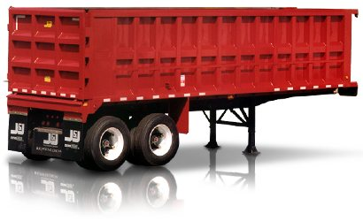

Resource: Dump Truck-Off Road
Category: | Public Works and Engineering (ESF #3) |  |  |  |  | Kind: | Equipment
Minimum Capabilities: |  |  | Type I | Type II | Type III |  |  | Type IV | Other
Component |  | Metric
Example |  |  | (Caterpillar Off-Highway) 769D  Caterpillar 3408E engine | (Caterpillar Quarry) 771D  Caterpillar 3408E engine
Gross Power |  | kw/hp | 386/518 | 386/518
Flywheel Power |  | kw/hp | 363/487 | 363/487
Net Power |  | kw/hp | 363/486 | 363/487
Maximum Torque |  | N/m/1,618 lb ft | 2,194 | 2m186
Gross Machine Weight |  | kg/lbs | 71,400/157,000 | 75,700/166,500
Operating (Empty) Weight |  | kg/lbs | 11,100/24,471.28
Chassis Weight |  | kg/lbs |  | 23,000/50,600
Body Weight |  | kg/lbs |  | 10,350/23,000
SAE Capacity |  | m³/yd³ | 17/22.24 to 24.2/31.7 | 27.5/36
Payload Capacity |  | tonnes/tons | 36.4/40 to 36.58/40 | 41/45
Transmission (Forward 1 to 6) |  | kph/mph | 12.6/7.8 to 77.7/48.3 | 12.6/7.8 to 57.3/35.6
Transmission (Reverse) |  | kph/mph | 16.6/10.3 | 16.6/10.3
Fuel Tank |  | L/gal | 530/140 | 530/140
Cooling System |  | L/gal | 113.5/30 | 113.5/30
Crankcase |  | L/gal | 45/12 | 45/12
Differentials and Final Drives |  | L/gal | 83/22 | 83/22
Steering Tank |  | L/gal | 34/9 | 34/9
Steering System with Tank |  | L/gal | 56/15 | 56/15
Brake Hoist with Tank |  | L/gal | 277/73 | 277/73
Torque Converter and Transmission with Sump |  | L/gal | 72/19 | 72/19
Inside Body Length |  | mm/in | 5,275/207.68 | 5,275/207.68
Overall Length |  | mm/in | 8,039/316.5 | 8,039/316.5
Wheelcase |  | mm/in | 3,713/146.18 | 3,713/146.18
Ground Clearance |  | mm/in | 627/24.68 | 627/24.68
Loading Height (Empty) |  | mm/in | 3,143/123.74 | 3,143/123.74
Operating Width |  | mm/in | 5,069/199.57 | 5,069/199.57
Centerline Front Tire Width |  | mm/in | 3,102/122.13 | 3,102/122.13
Front Canopy Height |  | mm/in | 3,952/155.59 | 3,952/155.59
Tires |  |  | Standard: 18.00-R33 (E4) | Standard: 18.00-R33 (E4)
Comments: |  | Caterpillar was used only for example purposes.  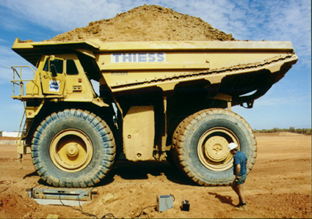

Resource: Dump Truck-On Road
Category: |  | Public Works and Engineering (ESF #3) |  |  |  | Kind: | Equipment
Minimum Capabilities: |  |  | Type I | Type II | Type III |  |  | Type IV | Other
Component | Metric
Equipment |  |  | Triple Axle | Tandem Axle | Single Axle
 |  |  | DOT Class 8; GVW rating 80,000; Capacities  16-20 yards of aggregate material and demolition debris; Diesel powered with choice of Manual or Automatic Transmission; Air Brakes; Limited off-road service; Medium to long haul; Wide turning radius; CDL license required | DOT Class 8; GVW rating 60,000; Capacities  10-14 yards of aggregate material and demolition debris; Diesel powered with choice of Manual or Automatic Transmission; Air Brakes; Limited off-road service; Medium to long haul; Wide turning radius; CDL license required | DOT Class 7; GVW rating 32,000; Capacities 5-8 yards of aggregate material and demolition debris; Diesel or gas powered with choice of Manual or Automatic Transmission; Air or Hydraulic Brakes; Limited off-road service; Short to medium haul; Short turning radius; CDL license required
Comments: | 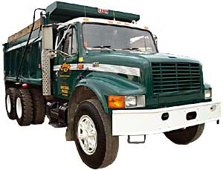

Resource: Electrical Power Restoration Team (Example)
Category: |  | Public Works and Engineering (ESF #3) |  |  |  | Kind: | Team
Minimum Capabilities: |  |  | Type I | Type II | Type III |  |  | Type IV | Other
Component | Metric
Personnel |  |  | - 5 overhead (2 person) crews with material handlers  - 1 overhead (2 person) crew  - 2 designers  - 1 team leader  - 1 safety specialist  - Fleet services support
Equipment |  |  | - Digger derrick/pole trailer  - Auxiliary bucket (material handler or 36’ bucket)
Comments: | Electrical Power Restoration Teams coordinate and support resources of energy producers to quickly restore electrical power to afflicted areas. Members should possess the experience and financial capabilities to support equipment and personnel, and to maintain operations for an indefinite period of time. Teams are “Site-Specific” and dependent on personnel and equipment deployment. The above type is only one example of said resource.

Resource: Engineering Services
Category: | Public Works and Engineering (ESF #3) |  |  |  |  | Kind: | Services
Minimum Capabilities: |  |  | Type I | Type II | Type III |  |  | Type IV | Other
Component |  | Metric
Damage Assessment Capability |  |  | Ability to determine the safety of buildings for occupancy purposes per the Applied Technology Council  ATC-20 criteria; Ability to evaluate buildings using the ATC-20 Rapid Evaluation Safety Assessment Form; Ability to evaluate buildings using the ATC-20 Detailed Evaluation Safety Assessment Form; Ability to support the need for an owner-provided Engineering Evaluation; Ability to evaluate safety of transportation structures per Federal Highway Administration Damage Assessment procedures and forms; Ability to evaluate damage for Stafford Act cost recovery purposes | Damage Assessment Capability
Support |  |  | Ability to support USAR teams, debris management, HazMat evaluation, traffic management, utility restoration, and water and wastewater quality evaluations | Support
Training |  |  | Knowledge of the ATC-20 criteria, Stafford Act cost recovery procedures, and Federal Highway Damage Assessment procedures; Extensive backgrounds in chemical, civil, electrical, and mechanical engineering, as appropriate | Training
Comments: |  | Engineering services encompass small firms to large national firms, and private to government-managed offices. Personnel must be certified and capable of handling assigned tasks, proven successes, and licensed, must have worked with public sector, and must be familiar with the Stafford Act, the Federal Highway Administration, and other Federal, State, Territorial, Tribal, and local agencies (and familiar with their requirements) for recording purposes. Engineering Services is one type based on the need to create the necessary engineering services based on “Incident-Specifics.” The makeup of the engineering services will be based on the discipline specialization of the disaster.

Resource: Flat Bed Trailer Truck (one type/example only)
Category: | Public Works and Engineering (ESF #3) |  |  |  |  | Kind: | Equipment
Minimum Capabilities: |  |  | Type I | Type II | Type III |  |  | Type IV | Other
Component |  | Metric
Equipment |  |  | Example Only
Trailer Length |  | ft | 18
Bed |  | in | 96
Slope |  | ft | 2
Axles |  | lbs | 6,000
GVWR |  |  | 12,000
Ramp with Adjustable Height Pintle |  | in | 60
Ground Clearance |  | in | 56
Weight |  | tons | 6 to 25
Transport |  | tons | 25 to 100
Air Operated Breaks |  | in x in | 16.5 x 7
Wide Spread |  | in | 122
Marker Lights Per Side |  |  | 5
Stop, Tail, and Turn Lights Per Side/Rear |  |  | 3
Comments: |  | There is one type because of the generality of the flat bed trailer; however, the capacity and hauling function of the trailer will vary with differing length and configurations. The above is only an example.  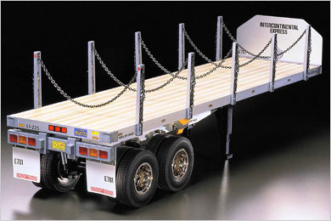

Resource: Generators
Category: |  | Public Works and Engineering (ESF #3) |  |  |  |  |  | Kind: | Equipment
Minimum Capabilities: |  |  | Type I |  | Type II | Type III |  |  |  | Type IV |  | Type V
Component | Metric
Equipment | KW |  | XQ2000  2000 kW Generator; Sound attenuated; Trailer mounted (semi tractor); Up to 3015 Amps@ 480 Volts, 3 Phase, 60 Hz; Dry weight 89,000 lbs; Fuel tank capacity 1250 Gallons; Dimensions 40’ Long x 8’ Wide x 13’.5” Tall;  Potential application example—Single or multiple units for: Power plants, heavy industrial facility, high-rise buildings;  Setup time (cables from generator to main power feed estimated at 5+ hours) |  | XQ1500  1500 kW Generator, Sound attenuated; Trailer mounted (semi tractor); Up to 2260 Amps@ 480 Volts, 3 Phase, 60 Hz; Dry weight 59,000 lbs; Fuel tank capacity 1250 Gallons; Dimensions 40’ Long x 8’ Wide x 13’.5” Tall;  Potential application example—Single or multiple units for: Universities, hospitals, medium to large manufacturing facility;  Setup time (cables from generator to main power feed estimated at 5+ hours) | XQ600  600 kW Generator; Sound attenuated; Trailer mounted (semi tractor); Up to 2080 Amps@ 208 Volts, 3 Phase, 60 Hz / up to 902 Amps@ 480 Volts 3 Phase, 60 Hz; Dry weight 37,000 lbs; Fuel tank capacity 660 Gallons; Dimensions 40’ Long x 8’ Wide x 13’.5” Tall;  Potential application examples: Retail stores, HVAC system power, multi-story/buildings, light manufacturing, apartment buildings; Setup time (cables from generator to main power feed estimated at 3+ hours) |  |  |  | XQ400  400 kW Generator; Sound attenuated; Trailer mounted (pull behind); Multi-voltage distribution panel; Up to 1390 Amps @ 208 Volts, 3 Phase, 60 Hz/up to 602 Amps@ 480 Volts 3 Phase, 60 Hz; Dry weight 16,800 lbs; Fuel tank capacity 470 Gallons; Dimensions 23’ Long x 8’.5” Wide x 11’ Tall;  Potential application example: Large office building, public schools, libraries, and communication equipment.  Setup time (cables from generator to main power feed estimated at 2+ hours) |  | XQ125  125 kW Generator; Sound attenuated; Trailer mounted (pull behind); Multi-voltage distribution panel; Up to 433 Amps@ 208 Volts, 3 Phase, 60 Hz / up to 188 Amps @ 480 Volts 3 Phase, 60 Hz; Dry weight 10,610 lbs; Fuel tank capacity 223 Gallons; Dimensions 18’.5” Long x 6’.5” Wide x 9’ Tall;  Potential application example: Small office building, emergency mobile trailers & operations, restaurants.  Setup time (cables from generator to main power feed estimated at 1 hour)
Comments: | 2500-gallon external fuel tanks available. Fuel consumption is estimated at 7% of the kW usage (example: fuel consumption on a 100 kW Generator operating at full load is approximately 7 gallons per hour). Technicians are available for hookup and monitoring of equipment. 4/0 Quick connect (Cam-Lock) cable is available for tie-in to power feed, rated at 400 Amps each cable. Fuel supply, and/or fuel vendors available. Power distribution equipment available. Transformers & Load Banks are available.
 | XQ2000 |  |  | XQ1500 |  |  | XQ600-400 |  |  |  | XQ125
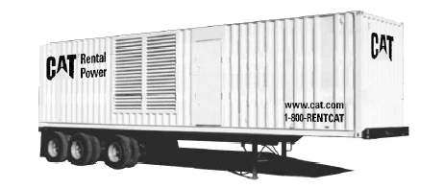
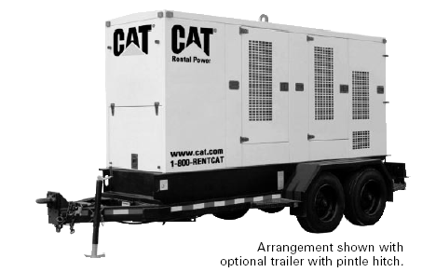
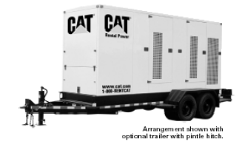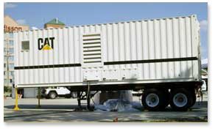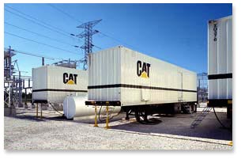

Resource: Hydraulic Excavator (Large Mass Excavation 13 cy to 3 cy buckets)
Category: |  | Public Works and Engineering (ESF #3) |  |  |  |  |  | Kind: | Equipment
Minimum Capabilities: |  |  | Type I |  | Type II | Type III |  |  |  | Type IV |  | Other
Component | Metric
Equipment | Cubic Yard |  | 5130B ME  Net HP (800); Operating Weight-Std. (399000 lb); Bucket Capacity-HDR (13.7 yd3); Max. Digging Depth (27.6 ft); Max. Reach at Ground Level (48.9 ft); Max. Dump Height (29.8 ft); Max. Drawbar Pull (196000); Fuel Tank (987 gal); Overall Width (21.7 ft); Height To Top Of Cab (21.4 ft); Track Length-Std. (23.8 ft) Mining Machine |  | 385B–L  Net HP (513); Operating Weight-Std. (183940 lb); Operating Weight-Long (L) Undercarriage (189770 lb); Bucket Capacities-HDR (2.5 yd3) - General Purpose GP (5.5 yd3); Max. Drawbar Pull (132810); Fuel Tank (328 gal); Max. Digging Depth (38.7 ft); Max. Reach at Ground Level (56.11 ft); Max. Dump Height (37.11 ft); Minimum Loading Height (11.1 ft); Overall Width (12.7 ft); Height To Top Of Cab (12 ft); Track Length-Std. (19.2 ft) | 375–L, 365B—L Series II  In respective order of size;  Net HP (428-404); Operating Weight-Std. (173100 lb-149000 lb); Operating Weight-Long (L) Undercarriage (179800 lb-150200 lb); Bucket Capacities-HDR (2.5 yd3-1.6 yd3) - General Purpose GP (5 yd3); Max. Drawbar Pull (126300 -103820); Fuel Tank (261gal--211 gal); Max. Digging Depth (37.7ft-31 ft); Max. Reach at Ground Level (52ft-46 ft); Max. Dump Height (33.11ft-30 ft); Overall Width (13.6ft--11.6ft); Height To Top Of Cab (12.2ft-11.11ft); Track Length-Std. (20.10 ft-19.3ft)
Comments: | To better match bucket needs to material conditions, contact dealer and or owner. The reference to “L” means Long Undercarriage. Mobilization may require more than one truck-trailer.
 | 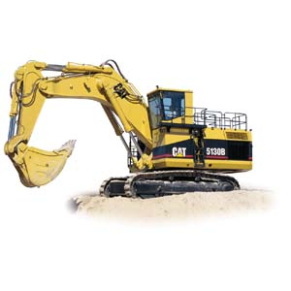 |  |  | 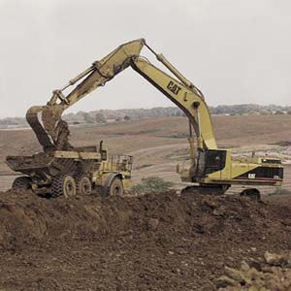 |  |  | 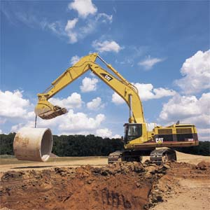 |  |  |  | 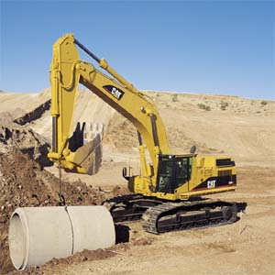
 | 5130B |  |  | 385B & L |  |  | 375 & L |  |  |  | 365B L Series II

Resource: Hydraulic Excavator (Medium Mass Excavation 4 cy to 1.75 cy buckets)
Category: |  | Public Works and Engineering (ESF #3) |  |  |  |  |  | Kind: |  | Equipment
Minimum Capabilities: |  |  | Type I |  | Type II |  | Type III |  |  |  | Type IV |  | Other
Component | Metric
Equipment | Cubic Yard |  | 345B L Series II  Net HP (321); Operating Weight-Long Undercarriage (111180 lb for UHD―97940lb); Bucket Capacity-HDR (3 yd3); Bucket Capacities General Purpose GP (4 yd3); Max. Digging Depth (23.7 ft); Max. Reach at Ground Level (37.2 ft); Max. Loading Height (22.6 ft); Max. Drawbar Pull (74380 lb); Fuel Tank (190 gal); Overall Width (11.5 ft); Height To Top Of Cab (15.1 ft); Track Length-Std. (17.7 ft) |  | 330C-325C L  In respective order of size;  Net HP (247-188); Operating Weight-Long Undercarriage (77400 lb-63100 lb); Bucket Capacities-HDR (2.12 yd3-1.75 yd3); Bucket Capacities General Purpose GP (3 yd3-2.5 yd3); Max. Drawbar Pull (66094 lb--54853 lb); Fuel Tank (163 gal-132 gal); Max. Digging Depth (24.3 ft-23.3 ft); Max. Reach at Ground Level (35.10 ft-34.6 ft); Max. Loading Height (23.7 ft-23.4 ft); Minimum Loading Height (8.11 ft-8 ft); Overall Width (11.3 ft-11.1 ft); Height To Top Of Cab (11 ft-10.11 ft); Track Length-Std. (16.6 ft-15.3 ft) |  | 322C L-320C L **Note  In respective order of size;  Net HP (168-138); Operating Weight-Long Undercarriage; (53600 lb-46300 lb); Bucket Capacities-HDR (2.12 yd3--1 yd3) - General Purpose GP (3 yd3-1.75 yd3); Max. Drawbar Pull (50132 -44040); Fuel Tank (132 gal-106 gal); Max. Digging Depth (22 ft-22 ft); Max. Reach at Ground Level (32.10 ft-32.4 ft); Max. Loading Height (22.1ft-21.4 ft); Overall Width (11.6ft-9.6 ft); Height To Top Of Cab (10.9-9.11ft); Track Length-Std. (15.3 ft-13.4ft) |  |  |  | 321B L-320C L Utility Models **Note  In respective order of size;  Net HP (168-138); Operating Weight-Long Undercarriage; (50927 lb-50700 lb); Max. Drawbar Pull (44063 -44040); Fuel Tank (66 gal-gal); Bucket capacities and other handling performances will be similar to 320 C L
Comments: | To better match bucket needs to material conditions, contact dealer and or owner. The reference to “L” means Long Undercarriage. Mobilization may require more than one truck w/trailer. Boom type will change reach, digging depth, and handling performances. **Note: 320C L has two versions for difference applications. Utility model has smaller radius.
 | 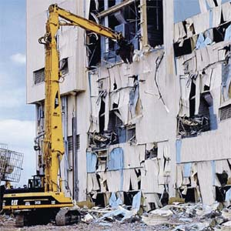 |  |  | 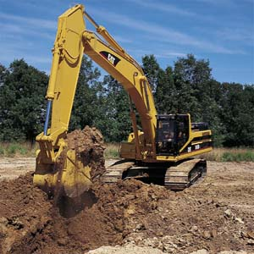 |  | 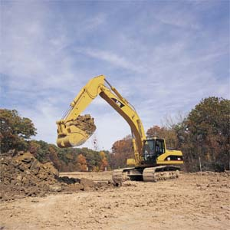 |  |  | 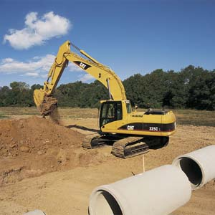 |  |  | 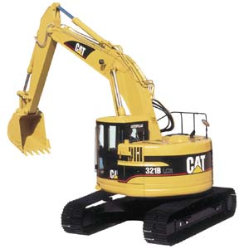
 | 345B L Series II UHD |  |  | 345B L Series II |  | 330C-325C L |  |  | 322C-320C L |  |  | 321B-320C L Utility

Resource: Hydraulic Truck Cranes
Category: |  | Public Works and Engineering (ESF #3) |  |  |  | Kind: | Equipment; Personnel; Vehicle
Minimum Capabilities: |  |  | Type I | Type II | Type III |  |  | Type IV | Other
Component | Metric
Equipment & Personnel | Tons |  | 75-70  Crane type with boom reach of 190-170 feet; With jib add approx. 30 feet; Self-propelled/driven over the road; Operator furnished; Setup time minimal; Counter weight transported by tractor-trailer; No other special transport permit required | 65-60  Crane type with boom reach of 160-150 feet; With jib add approx. 30 feet; Self-propelled/driven over the road; Operator furnished; Setup time minimal and ready for use; No special transport permit required | 40-35  Crane type with boom reach of 140 feet; With jib add approx. 30 feet; Self-propelled/driven over the road; Operator furnished; Setup time minimal and ready for use; No special transport permit required
Comments: | Check with your local/State transportation and law enforcement organizations to determine mobilization requirements.
 | 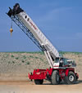

Resource: Lattice Truck Cranes
Category: |  | Public Works and Engineering (ESF #3) |  |  |  | Kind: | Equipment; Personnel; Vehicle
Minimum Capabilities: |  |  | Type I | Type II | Type III |  |  | Type IV | Other
Component | Metric
Equipment | Tons |  | 220  Manitowoc  Reach of 430 feet;  Requires 7 tractor-trailers to mobilize & demobilize; Setup time 6 hours
Personnel |  |  | Operator with one (1) oiler/rigger
Comments: | Check with your local/State transportation and law enforcement organizations to determine mobilization requirements.

Resource: Track Dozer
Category: | Public Works and Engineering (ESF #3) |  |  |  |  | Kind: | Equipment
Minimum Capabilities: |  |  | Type I | Type II | Type III |  |  | Type IV | Other
Component |  | Metric
Example |  |  | D10R – Cat 3412E Turbo Charged Diesel | D6N – Cat 3126B Diesel | D3G – Cat 3046 Diesel |  |  |  | D10R WHA (Waste Handling) – Cat 3412E Turbo Charged Diesel
Gross Power |  | RPM | 1,900 | 2,100 | 2,400 |  |  |  | 1,900
Gross Power |  | kw/hp | 457/613 | 127/170 | 57/77 |  |  |  | 457/613
Operating Weight |  | lbs | 144,191 | 34,209 | 16,193 |  |  |  | 144,986
Blade Capacity |  | yd³ | 24.2 | 5.6 | 1.88 |  |  |  | 63.9
Digging Depth |  | in | 26.5 | 20.5 | 21.8 |  |  |  | 26.5
Height |  | ft/in | 6’11” | 4’1” | 3’.8” |  |  |  | 10’5”
Ground Clearance |  | ft/in | 4’11” | 3’2.7” |  |  |  |  | 4’10”
Total Tilt |  | ft/in | 3’3” | 2’2.2” | 1’2.5” |  |  |  | 3’6.3”
Width Over End Bits |  | ft/in | 15’11” | 10’6” | 8’.9” |  |  |  | 17’3”
Blade Lift Height |  | in |  |  | 27.1
Digging Depth |  | in |  |  | 21.8
Multishanks Arrangements |  |  | 1-3 | 3 |  |  |  |  | 1 to 3
Ground Clearance Under Tip |  | in | 35 | 19.9 | 16.2 |  |  |  | 35”
Machine Ground Clearance |  | in |  |  | 14.7
Max Penetration |  | in |  | 14.2 |  |  |  |  | 3’1”
Max Reach at Ground Line |  | in |  | 29.1 | 29.1”
Width |  | ft/in | 9’7” | 7’2.7” | 8’.9” |  |  |  | 9’7”
Winch-Drum Capacity |  | ft | 226 | 371 | 371 |  |  |  | 226
Fuel Capacity |  | gal | 293 | 79 | 43.6 |  |  |  | 293
Max Line Pull Bare Drum |  | lbs |  |  | 40,000
Full Drum |  | lbs |  |  | 25,000
Comments: |  | Caterpillar is used as an example only. The major difference for D10R WHA (Waste Handling) – Cat 3412E Turbo Charged Diesel is that it contains a larger blade and protection guards to prevent landfill type debris from tangling its drives.  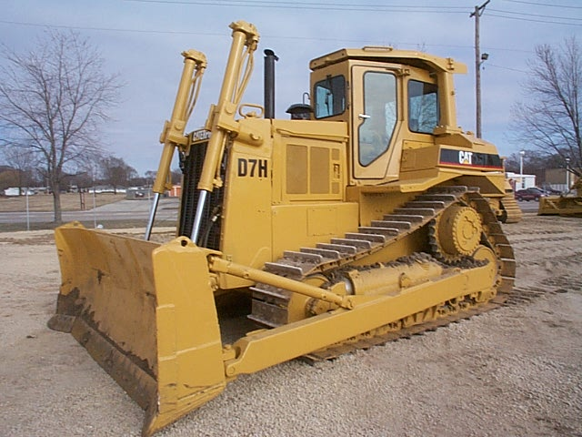  General Example  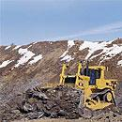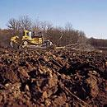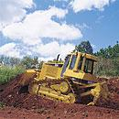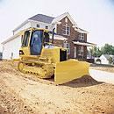  D10R D10R WH D6N D3G

Resource: Tractor Trailer (Example Only)
Category: |  | Public Works and Engineering (ESF #3) |  |  |  | Kind: | Equipment
Minimum Capabilities: |  |  | Type I | Type II | Type III |  |  | Type IV | Other
Component | Metric
Example |  |  | TE70FG-2 Folding Gooseneck Trailer | TE18AH (D9AH) General Duty Hydraulic Tail Trailer (with Fifth-Wheel Hookup)
Capacity | lbs |  | 70,000 | 18,000
Overall Length | ft/in |  | 40’-53’ | 34’11”
Main Deck Length (Double Drop) | ft |  | 17-28 | 8
Hydraulic Deck Plate | in |  |  | 18
Arch Hitch Length | ft/in |  |  | 7’9”
Arch Hitch Height | in |  |  | 32-40
Main Deck Length (Single Drop) | ft |  | 20-32
Upper Deck Length | ft |  | 8
Rear Deck Length | ft/in |  | 7’-10’
Slope | degrees |  | 60
Width | ft/in |  | 8’6” | 8’
Swing Clearance | in |  | 84
King Pin Setting | in |  | 16
Deck Height (Unloaded Single Drop) | in |  | 39.5
Deck Height (Loaded) | in |  |  | 36
Ground Clearance (Single Drop) | in |  | 19.5
Platform | in |  | 1.375 | 1.375
Axles (2) | lbs |  | 25,000 | 9,000
Brakes (Air) | in x in |  | 16.5 x 7 | 12.25 x 3.375
Wheels (Disc-Pilot Mounted) |  |  | 8.25 x 22.5
Wheels  (8-Hole) |  |  |  | 6.75 x 16.5
Tires (Low Profile) |  |  | 255/70R x 22.5
Tires  (10-Ply) |  |  |  | 8.75 x 16.5
Suspension |  |  | Spring-type | 18,000 lbs
Jack (Crank Style with Pin Drop Base) | lbs |  |  | 12,000
Comments: | Rail-EZE Trailers are used only as an example.  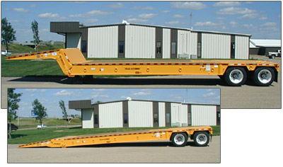  TE70FG-2 Folding Gooseneck Trailer  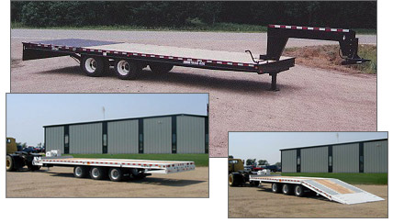  TE18AH (D9AH) General Duty Hydraulic Tail Trailer (with Fifth-Wheel Hookup)

Resource: Tub Grinder
Category: |  | Public Works and Engineering (ESF #3) |  |  |  | Kind: | Equipment
Minimum Capabilities: |  |  | Type I | Type II | Type III |  |  | Type IV | Other
Component | Metric
Output Capability | cy/hr |  | > 400 | 300-400 | 100-300 |  |  | Up to 100
Tub Size (opening) | ft/in |  | 14’-15’ | 12’-13’ | 8’4”-11’ |  |  | Up to 8’4”
Towing Arrangement (i.e., Tow-Behind and Fifth-Wheel Trailer Hookup) |  |  | Fifth-wheel | Fifth-wheel | Fifth-wheel |  |  | Pintle hitch
Horsepower | hp |  | >1000 | 630-1000 | 200-575 |  |  | Up to 200
Example |  |  | Mobark 1500 | Morbark 1300/1200XL | Morbark 1100/1000 |  |  | Mobark 950
Comments: | Morbark is used as an example only.  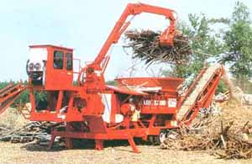

Resource: Tug Boat
Category: | Public Works and Engineering (ESF #3) |  |  |  |  | Kind: | Equipment
Minimum Capabilities: |  |  | Type I | Type II | Type III |  |  | Type IV | Other
Component |  | Metric
Vessel Personnel |  |  | Tug Boat Captain | Inland River Pilot | Docking Pilot
Description |  |  | Term used on the inland waterways to describe a vessel operator who holds a Master license | Term used on the inland waterways that equates to "Mate" in the coastal sector; A pilot is the second operator onboard an inland towing vessel; The pilot has similar navigation duties and credentials to the Captain/Master, although the Captain/Master has the ultimate authority onboard the vessel | A docking pilot is an individual with specific expertise in maneuvering large, deep sea vessels in confined spaces (e.g., alongside a pier); The docking pilot boards the ship, takes the conn, and brings the vessel into port; Most docking pilots are licensed by the Coast Guard (except in Maryland and New Jersey, where they are licensed by the State) and are employed by tug companies
Training or Requirements |  |  | Requires a tug boat captain’s licensure issued by the U.S. Coast Guard; Increasingly,  2-month schools are available for captain licensure | Requires licensure issued by the U.S. Coast Guard | Requires special licensure issued by the U.S. Coast Guard or New Jersey/ Maryland
Crew Availability |  |  | Generally live on the boat during working times, as schedule depends on the tug boat companies (e.g., 4 days on, 4 days off) | Required by law and on an on-call basis | Specialty position on an  on-call basis
Comments: |  | Tug boats are typed as one resource as modifications and enhancements are based on boat-to-boat, location, and working task specialty bases. Tug boats and operators are subject to licensure and jurisdiction of the U.S. Coast Guard, and are required by law to make use of river pilots on inland waterways. The docking pilot specialist is becoming more used in current times. Horsepower will be the first determining factor in tug boat requisitioning, as tractor tugs are the preferred equipment type. Equipment is usually requisitioned from a U.S. Coast Guard or harbor-master matrix based on the closest and largest available tug boat. The matrix will assign the tug type, size, and how many units may be available to assist in the emergency situation.  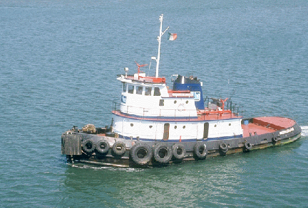

Resource: Water Purification Team (USACE Emergency Water Teams)
Category: | Public Works and Engineering (ESF #3) |  |  |  |  | Kind: | Team
Minimum Capabilities: |  |  | Type I | Type II | Type III |  |  | Type IV | Other
Component |  | Metric
Team Personnel |  |  | ESF Action Officer (AO) | Mission Manager | Mission Specialist |  |  | Logistics Manager | Contract Specialist
Description |  |  | Coordinates the mission requirements on all levels with FEMA, State, local, and other ESF elements to determine scope of mission; Is the USACE liaison with FEMA, DFO, and ERRO, and provides tasking to the ERRO/District; Works with Mission Manager to ensure actions are accomplished | Serves as the Project Manager for mission execution and is responsible for team coordination and timely procurement and delivery of water to all staging areas and distribution sites; Prepares scopes of work, cost estimates, schedule and tracking of water deliveries, and upward reporting | Works with the ERRO and assists the Mission Manager, while serving as the MM backup (same relative duties) |  |  | Works at the staging operations area and provides support for the MM; Responsible for receiving, inventory management, and distribution of emergency water in coordination with the MM; Ensures the quality control and accounting necessary for upward reporting and contractor payments; Provides status reports of deliveries and inventories | Works for the Chief of the Contracting Division of the supported District and ERRO, and contract support to the MM; Responsible for all contracting for the procurement, transportation, storage, security, testing, and distribution of water during emergency operations; Provides copies of all ACI Contract actions and delivery orders
Training or Requirements |  |  | Must have full knowledge of the Federal Response Plan, FEMA operations, PL 84-99 authorities, and operational dynamics of a DFO | Must be familiar with the procurement process and able to communicate mission requirements to contracting, resource management, emergency management, and other impacted districts; Trained and fully knowledgeable of the current ACI Water Contract, and familiar with the ENGLink Interactive and the preparation of SITREPS, CEFMS, and the PR&C process (requires an alternate to be designated) | Must be familiar with the procurement process and able to communicate mission requirements to contracting, resource management, emergency management, and other impacted districts; Trained and fully knowledgeable of the current ACI Water Contract, and familiar with the ENGLink Interactive and the preparation of SITREPS, CEFMS, and the PR&C process (requires an alternate to be designated) |  |  | Must possess special  training for receiving and accountability process; Must be able to effectively work with emergency managers to solicit support for Logistics PRT (requires an alternate person be designated) | Must be able to act as liaison between Water PRT and the Contracting Division of supported District, while scoping contract requirements for mission execution and procurement; Must be fully knowledgeable of the current ACI Water Contract, delivery orders, preparing sealed bids, negotiate actions, simplified acquisition procedures, and must be proficient in the Standard Procurement System, Procurement Desktop Defense, and CEFMS
Crew Availability |  |  | Deployed for 30-day rotations, with a 3- to 5-day transition period between consecutive missions; Average missions last  2-3 weeks | Deployed for 30-day rotations, with a 3- to  5-day transition period between consecutive missions; Average missions last 2-3 weeks | Deployed for 30-day rotations, with a 3- to 5-day transition period between consecutive missions; Average missions last  2-3 weeks (nightshift availability if required) |  |  | Deployed for 30-day rotations, with a 3- to 5-day transition period between consecutive missions; Average missions last  2-3 weeks; multiple deployments required (nightshift availability if required) | Deployed for 30-day rotations, with a 3- to 5-day transition period between consecutive missions; Average missions last  2-3 weeks
Water Sources |  |  | ACI Water Contract | Commercial Water Sources | Reverse Osmosis Water Purification Units (ROWPUs)
Description |  |  | A service and supply contract which can be used to provide bottled and bulk water:  Area of Coverage:  Continental U.S. (CONUS) and  Outside Continental U.S. (OCONUS)  Time Requirement:  Within 24 hours  Bottle Size: 12 ounce to 1.5 liter  Conversion Factor:  1 gallon = 3.79 liters  Price: 0.38/liter for CONUS  Bulk Water: Scope and cost to be negotiated based on water source and transportation method | Commercial water sources can be located by contacting the International Bottled Water Association | Able to purify 3,000 gallons of potable water an hour; Detachments are typically equipped with a 2-million-gallon storage capability to pump this water  approximately 20 miles
Water Distribution |  | Recommendation (Note: emergency water is for drinking purposes only, and initial distributions should be based on 1 gallon/ person per day and limited to no more than 2 days supply per visit to ensure all residents have minimum amount for survival) | 1 gallon/person per day
Comments: |  | USACE – Emergency Water Team Staffing is designed to provide the minimum number of personnel to effectively manage and support the execution of the water mission in concert with the responding Emergency Response and Recovery Office command and control structure. The team configuration is designed to staff the three operational functions required to execute a major Federal Response Plan mission: Emergency Support Function #3 (Public Works and Engineering) element at the Disaster Field Office, Emergency Response and Recovery Office, and the Staging Operations area(s). The preferred method of providing water to disaster victims is by bottled water because the containers are usually stronger and easier to carry, and reduce opportunity for disease transmission as the water is consumed in a shorter period of time.

Resource: Water Truck (example only)
Category: |  | Public Works and Engineering (ESF #3) |  |  |  | Kind: | Equipment
Minimum Capabilities: |  |  | Type I | Type II | Type III |  |  | Type IV | Other
Component | Metric
Example |  |  | Tandem Axle
DOT Class 8; GVW rating 60,000; Capacity
4,000 gallons of potable water; Gas or diesel powered with choice of Manual or Automatic Transmission; Air Brakes; Limited off-road service; Medium to long haul; Wide turning radius; CDL license required
Comments: | 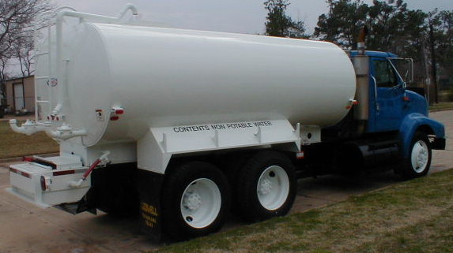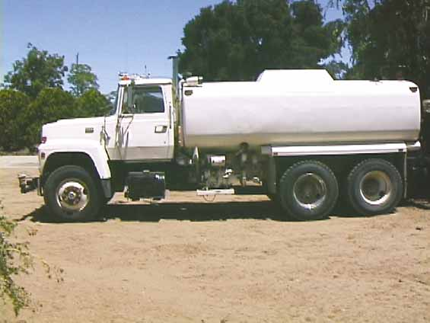  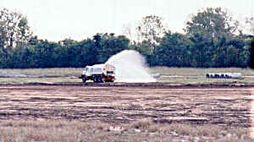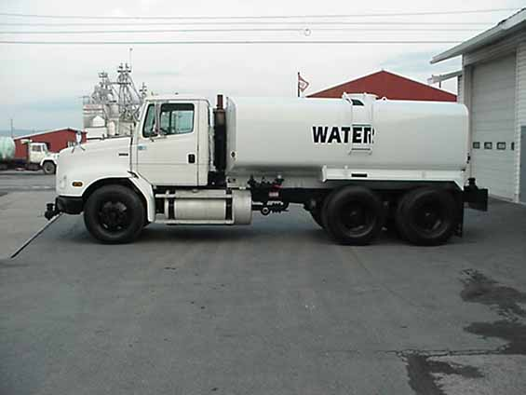

Resource: Wheel Dozer
Category: | Public Works and Engineering (ESF #3) |  |  |  |  | Kind: | Equipment
Minimum Capabilities: |  |  | Type I | Type II | Type III |  |  | Type IV | Other
Component |  | Metric
Example |  |  | 854G – Cat 3508B EUI Diesel All-Wheel-Drive | 824G – Cat 3406C Turbo Charged Diesel All-Wheel-Drive
Gross Power |  | RPM |  | 2,100
Gross Power |  | kw/hp | 656/880 | 254/340
Weight |  | lbs | 212,230 | 58,697
Blade Height |  | ft/in | 6’11” | 4’10”
Width |  | ft/in | 21’8”
Moldboard Length |  | ft/in |  | 13’9”
Maximum Depth of Cut |  | ft/in | 1’4” | 1’5”
Maximum Lift Above Ground |  | ft/in | 3’6” | 3’6”
Maximum Clearance Under Skid Plate |  | ft/in | 5’6” | 3’2”
Total Tilt |  | ft/in | 3’10” | 3’11”
Width Over End Bits |  | ft/in | 20’7” | 14’9”
Fuel Capacity |  | gal | 413 | 166
Comments: |  | Caterpillar is used as an example only.  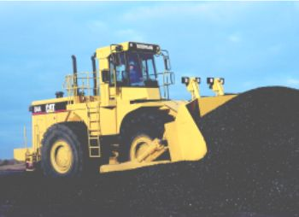  General Example  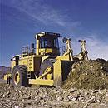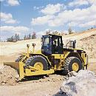  854G 824G

Resource: Wheel Loaders (Large 41 cy to 8 cy)
Category: |  | Public Works and Engineering (ESF #3) |  |  |  |  |  | Kind: | Equipment
Minimum Capabilities: |  |  | Type I |  | Type II | Type III |  |  |  | Type IV |  | Other
Component | Metric
Equipment | Cubic Yards |  | 994D  Gross Power 1027 kW (1375 hp); Operating Weight 191200 kg (421600 lb); Rated Payload-Standard 34.5 tonnes (38 tons); Bucket Capacity Range 15-31 m3 (19.5-41 yd3); Reach at Max. Lift/Dump-Std 2263 mm (7.4 ft); Clearance at Max. Lift/Dump-Std 5592 mm (18.4 ft); Bucket pivot at Max. Lift-Std 8157 mm (26.8 ft); Overall Height Bucket Raised-Std 100996 mm (36.1 ft); Overall Length-Std 16809 mm (55.1 ft); Width Over Tires 5499 mm (18 ft); Fuel Tank (1226 gal) |  | 992G  Gross Power 656 kw (880 hp);  Max. Bucket Capacity 12.3 m3 (16 yd3); Operating Weight 93779 kg (206783 lb); Dump Clearance 4636 mm (19 ft); Fuel Tank 413 gal) | 990 Series II  Gross Power 503 kW (675 hp); Operating Weight 77141 kg (170067 lb); Rated Payload-Standard 15 tonnes (16.5 tons); Bucket Capacity Range 8.4-9.2 m3 (11-12 yd3); Static Tipping Load, Full Turn 38243 kg (84311 lb); Reach at Max. Lift/Dump-Std 1799 mm (5.9 ft); Clearance at Max. Lift/Dump-Std 4135 mm (13.7 ft); Overall Length-Std 12839 mm (42.1 ft); Width Over Tires 4071 mm (13.3 ft); Fuel Tank (284 gal) |  |  |  | 988G  Gross Power 388 kW (520 hp); Operating Weight 50183 kg (110634 lb); Rated Payload-Standard 11.4 tonnes (12.5 tons); Bucket Capacity Range 6.3-7 m3 (8.2-9.2 yd3); Static Tipping Load, Full Turn 26960 kg (59436 lb); Reach at Max. Lift/Dump-Std 2113 mm (6.9 ft); Clearance at Max. Lift/Dump-Std 3971 mm (13 ft); Overall Length-Std slightly less that 990 Series; Fuel Tank (176.5 gal)
Comments: | Caterpillar products used in typing. To better match bucket needs to material conditions, contact dealer and or owner.
 | 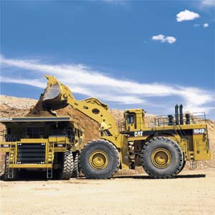 |  |  | 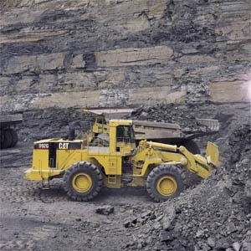 |  |  | 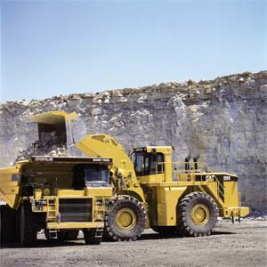 |  |  |  | 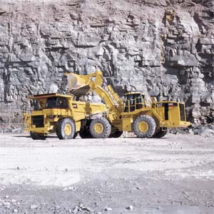
 | 994D |  |  | 992G |  |  | 990 Series |  |  |  | 988G

Resource: Wheel Loaders (Medium 7 cy to 3 cy)
Category: |  | Public Works and Engineering (ESF #3) |  |  |  |  |  | Kind: | Equipment
Minimum Capabilities: |  |  | Type I |  | Type II | Type III |  |  |  | Type IV |  | Other
Component | Metric
Equipment | Cubic Yards |  | 980G, 972G  In respective order;  Max. Flywheel Power 238 kW-213 kW (319 hp-285 hp); Operating Weight 30207 kg-25490 kg (66576 lb-56180 lb); Static Tipping Load 18032 kg (39743 lb); Breakout Force 210 kN (47277 lb);  Bucket Capacity Range 3.8-5.7m (7.5-5 yd3); Fuel Tank (124-100 gal) |  | 966G Series II  Max. Flywheel Power 194 kW (260 hp); Operating Weight 22870 kg (50400 lb); Bucket Capacity Range 3.5-4.25 m3 (4.5-5.5 yd3); Fuel Tank (100 gal) | 962G Series II, IT62G, 950G Series II  Max. Flywheel Power 157-146 kW (210-196 hp)  Operating Weight 18547-17780 kg (40889-39198 lb); Static Tipping Load 11966-10619 kg (26380-23411 lb); Breakout Force 154-125 kN (34666-28210 lb);  Bucket Capacity Range 2.7-3.8 m3 (5-3.5 yd3); Fuel Tank (75 gal) |  |  |  | 938G, IT38G  In respective order;  Max. Flywheel Power 128 kW (172 hp)  Operating Weight 13062-13030 kg (28731-28714 lb); Static Tipping Load 9241-7621 kg (20373-16800 lb); Breakout Force 109-124 kN (25096-28020lb);  Bucket Capacity Range 2.8-2.5 m3 (3.65-2.9 yd3); Fuel Tank (67 gal)
Comments: | Caterpillar products used in typing. To better match bucket needs to material conditions, contact dealer and or owner. IT models offer multiple attachments.
Comments: | 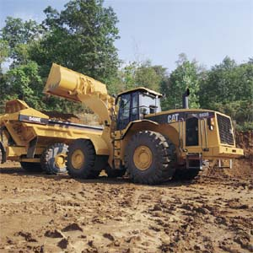 |  |  | 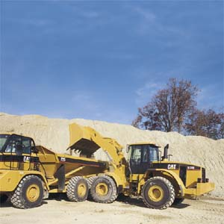 |  |  | 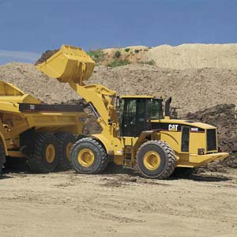 |  |  |  | 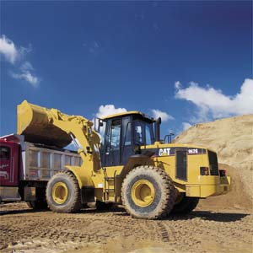
Comments: | 980G |  |  | 972G |  |  | 966G |  |  |  | 962G
Comments: | 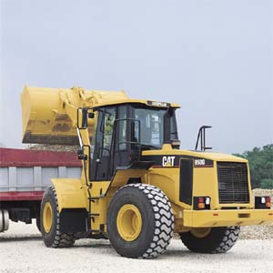 |  |  | 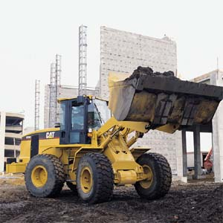 |  |  | 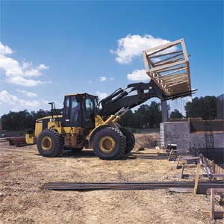 |  |  |  | 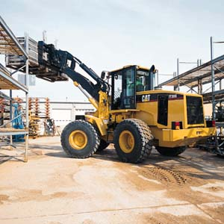
Comments: | 950G |  |  | 938G |  |  | IT62G |  |  |  | IT38G

Resource: Wheel Loaders (Small 7 cy to 2 cy)
Category: |  | Public Works and Engineering (ESF #3) |  |  |  |  |  | Kind: | Equipment
Minimum Capabilities: |  |  | Type I |  | Type II | Type III |  |  |  | Type IV |  | Other
Component | Metric
Equipment | Cubic Yards |  | 928G, IT28G  In respective order;  Max. Flywheel Power 107 kW (144 hp); Operating Weight 11836 kg-12134 kg (26094 lb-26751 lb);  Bucket Capacity Range 2-5.35 m3 (2.5-7 yd3); Fuel Tank (59 gal) |  | 924G, 924Gz  In respective order;  Max. Flywheel Power 98 kW (132 hp); Operating Weight 10328 kg-9844 kg (22769 lb-21702 lb);  Bucket Capacity Range 1.7-5 m3 (2.2-6.5 yd3); Fuel Tank (59-51 gal) | IT14G, 914G  In respective order;  Max. Gross Power 73 kW (98 hp); Operating Weight 7906 kg-7243 kg (17393 lb-15935 lb); Breakout Force (17270-14007 lb); Static Tipping Load (10094-11737 lb); Dump Clearance 9.58-8.75 feet; Bucket Capacity Range 1.4 m3 (1.8 yd3); Fuel Tank (59-51 gal)
Comments: | Caterpillar products used in typing. To better match bucket needs to material conditions, contact dealer and or owner. IT models offer multiple attachments.
Comments: | 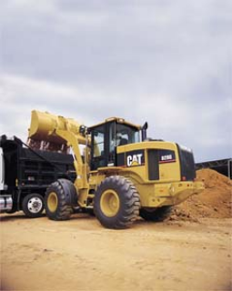 |  |  | 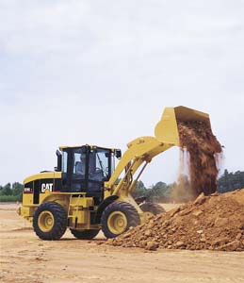 |  |  | 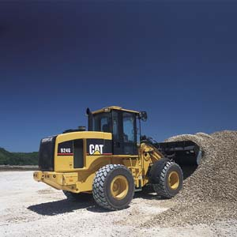 |  |  |  | 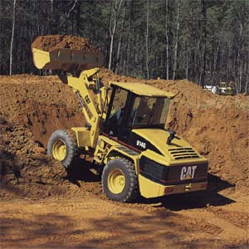
Comments: | 928G |  |  | IT28G |  |  | 924G |  |  |  | 924Gz
Comments: | 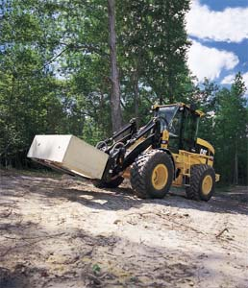 |  |  |  |  |  | 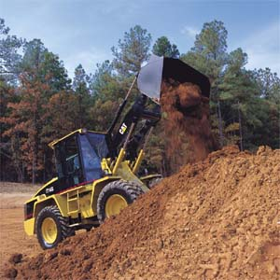
Comments: | IT14G |  |  |  |  |  | 914G

